Findings and Recommendations

Grainger PLC
MRI Implementation Consulting

Version 1.0
4 March 2021

Contents
1 Introduction 3
1.1 Background 3
1.2 Objectives 3
1.3 Definitions 4
2 Current State 5
2.1 Portfolio Requirements 5
2.2 Connect Platform 7
3 Recommendation 9
3.1.1 Our Experience with RM and CM MRI Modules 9
3.1.2 Addressing Initial Concerns 10
3.1.3 Feasibility 11
3.1.4 Other Benefits 13
4 Next Steps 15
5 Appendices 16
5.1 MRI HIERARCHY 16

Introduction

Background
Grainger PLC is the largest private landlord in the UK. Today, their core segment is Build-to-Rent, but their portfolio includes a number of legacy properties with various types of tenure and legislative restrictions. Grainger are in the process of implementing Connect, an integrated property management platform intended to replace their existing solution. Central to this solution is MRI Platform X.
During the design of the solution, a number of key limitations were encountered in applying Grainger’s portfolio and specific needs to MRI. This resulted in some key decisions as to how to apply the available property management modules (specifically Commercial Management vs. Residential Management), and various customisations to address accounting requirements.
As the solution moved into UAT, many issues were encountered, especially around performance. Grainger is now at a stage where they must make some key strategic decisions about the platform and how to move forward. Open Box Software has been engaged as an expert in MRI to help advise on options.

Objectives
As a priority, the following key questions have been identified by Grainger to be addressed in this investigation:
- Are the design decisions that have been made to date appropriate?
- If not, what other options or approaches can be recommended?
- Given this, what is the best way forward at this time?
These questions will be specifically focused on the following four key functional areas:
- Use of RM/CM Modules – ability to hold residential units of multiple tenures with different requirements in terms of billing, service charges etc.
- Ability to manage Service charge for blocks with units of multiple tenures including mixed ownership.
- Ability to do unit level account / apportion revenues and expenses across units.
- Ability to register intercompany transactions (including ‘capital’ transactions e.g. sale of property from one entity to another).

Definitions
For simplicity, we will use the following terminology in this document:
- Property: the asset as a whole. This may be a development or estate comprising of many separate homes, or an apartment block that represents a single physical building.
- Building: the logical structure within MRI, which may or may not correspond to a single physical building. One property might be split into several buildings in the current implementation.
- Unit: a lettable or sellable space within the property e.g. a flat, a house, a parking space, etc.
- Tenure Type: the regime of occupancy that applies to a given unit e.g. AST, Ground Rent, Assured, Shared Ownership.
- Unit Status: the current state of the unit e.g. tenanted, under development, void.

Current State

Portfolio Requirements
At a high level, Grainger’s portfolio encompasses a wide range of different tenure types, as well as mixed-use properties that may include commercial units. Many of these tenures may occur together within a single residential or mixed-use property. Each may have different billing frequencies and service charge recoverability rules.
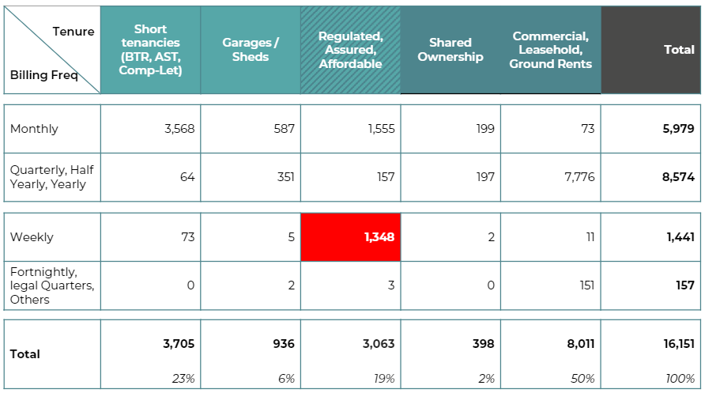
Figure 1: Billing Frequencies by Tenure Type
When it was initially realised that MRI’s RM module was unable to satisfy all portfolio requirements, three options were brought before the design authority for consideration:
- Option 1: Customise MRI RM to handle weekly charges.
- Option 2: Move regulated tenancies to CM.
- Option 3: Adjust processes to charge monthly and be paid weekly.
Option 2 ultimately won out: to resolve these inconsistencies, properties are currently split across two modules, with one property frequently represented by more than one building in MRI.

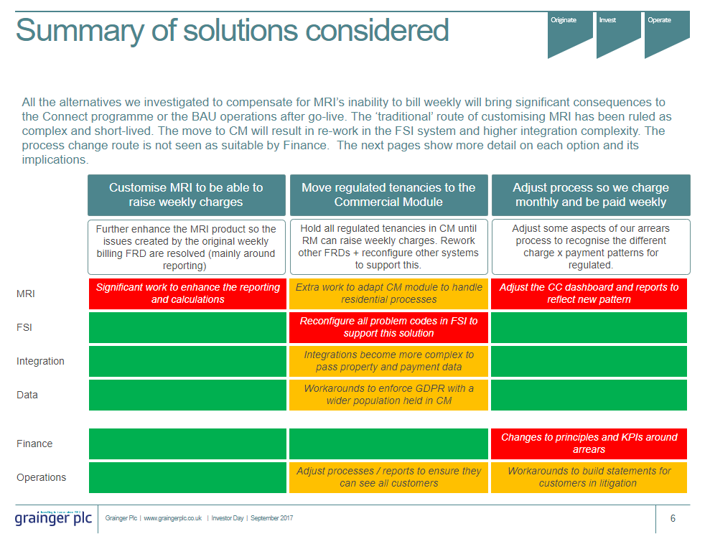
Figure 2: Solutions Considered

There are two factors that currently determine if a unit with a given tenure type must be implemented in Commercial Management (CM), as the Residential Management module does not cater for them:
- It has a weekly billing frequency (highlighted in red in the above table).
- Service charges apply and are recoverable.
As is typical for most asset classes with service charges, common charges need to be apportioned across all units and spaces, even those that are not recoverable or void. This is especially challenging in assets where multiple tenure types apply.
For example, the following different types of tenures may all apply within the same property:

Tenure Type | Rent Freq | Service Charges | Customer
AST | Monthly | No (common charges apportioned but not recoverable) | Private tenant
Regulated | Variable incl. Weekly | Yes (Within Rent) | Private tenant
AST - Affordable | Monthly | Yes (but SC+Rent capped at 80% market rate) | Private tenant
Leasehold, Nil Ground Rent | N/A | Yes | Private Leaseholder
Commercial Lease | Quarterly or Monthly | Yes | Company

Shared Ownership properties also exist where the customer owns only part of the unit and Grainger owns the other. This makes the customer both a tenant and leaseholder at the same time.
Further, different tenure types may fall under a different legal entity associated with the same property. Where a unit transitions from a regulated tenancy to a leasehold, this further complicates the process as the unit must be ‘sold’ to the other entity.
Finally, this structure creates additional complexity at the consolidation and reporting stage, in order to report on the asset as a whole.

Connect Platform
While MRI Platform X forms the core of the Connect ecosystem, it is by no means the only consideration. Integrations either have already been built or are required for early phases to and from the following systems:
- FSI Concept Evolution: property and supplier management, work orders
- ProActis: procure to pay – purchase orders, invoice processing
- Salesforce: marketing and lead-to-lease pipeline
- Leasing Portal, MyGrainger portal: customer-facing digital interfaces
- Asperato, GoCardless: payment platforms
- Docushare: Document storage
The integration is managed through a custom integration layer called GREP.
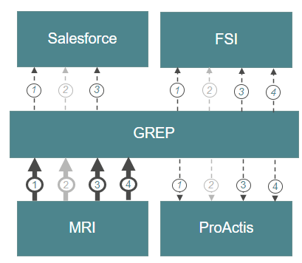
Figure 3: Master Data Integration – High Level Diagram

It is important to note that changes to the MRI solution will have a knock-on impact to this integrated model.
However, also of great relevance is the design of the GREP interface as a logic layer that performs the mapping and applies the business logic between systems. The various systems are in essence unaware of the rules that are applied in translating between them. This design allows for adjustments to rules without fundamentally changing the interfaces themselves.

Recommendation
If we were to receive a similar set of requirements for a new client today, our recommendation would be to use the CM module exclusively.
It is worth reflecting that this was not brought before the design authority as a fourth option for consideration, for many reasons:
- Part of the front end – the ‘leasing journey’ – was designed with the assumption it would interface with the RM module. So moving the regulated tenancies out of RM would not create much of an impact (since Grainger would not be leasing new regulated / assured tenancies anyway) but moving them all would make us rework a lot of that integration.
- MRI had always been adamant about the strengths of RM to manage residential tenants – like the ability to recognise different people sharing a flat, and the ability to move them in / out independently of the overall tenancy. Indeed, when it came to do the integration around contact data, the differences between RM and CM on how they treat / manage individuals made things much more complicated.
- The aspect of GDPR compliance of the CM module (i.e. the lack thereof) also was a concern at the time. Grainger devised solutions that would ensure the company as a whole remained compliant by compensating for the MRI lack. But something like this always meant that the CM use for residential tenants would be a temporary / workaround kind of approach.
All the above, plus the perception that the regulated portfolio was a declining one (which would eventually disappear) reinforced the perception that RM – by having a more suitable way of handling the ‘core’ PRS tenants – was the right solution for the long term.
We will therefore motivate our reasoning and address these concerns in detail in this section.

Our Experience with RM and CM MRI Modules
With over 10 years of experience working with MRI and becoming the first Global Services Partner to be certified, RM and CM have been at the core of our primary service offerings. We have worked with over 50 different clients in the US and EMEA regions, delivering more than 130 projects which include:
- Full system and single module implementations
- Customisations using the MRI Flexibility Toolkit
  - Web Design
  - Report Design
  - Database Design
  - Workflow Design
- Version upgrades
- Windows to web conversions
- Environment migrations, on-premise to SaaS
- Integrations using the MIX API platform
- General MRI Support
Having worked with MRI Software for a long period we have had front row seats in the evolution and development of RM and CM. Previously, the RM module was solely available to the US region. This meant that all other regions, including EMEA, were limited to CM to manage Residential, Commercial and Retail portfolios. Many of our EMEA region customers to this day are still able to make use of CM to manage their mixed-use portfolios.
Although in recent years, MRI Software has released a UK version of RM, the product is still finding its feet in the market. We do not doubt that in the future, MRI will develop the product to meet specific UK requirements especially as the adoption of the RM module in the market increases. We are currently unaware of a single client that has been able to significantly affect the development of the MRI roadmap.

Addressing Initial Concerns
- Leasing Journey: the assumption that all new leases would align to units in RM arose naturally from the assumed future state of the system. Designing the leasing journey around this assumption was a natural one. There is no denying that additional effort will be required to amend this process to integrate to CM, and may even mean that Salesforce has to pick up certain functions within this process that exist in RM but not CM, or that CM will need customisation to support this. However, many of our customers successfully manage lead-to-lease from Salesforce to CM, or from other CRM systems to ERPs with similar functionality to CM, so this is feasible.
- RM functionality: RM-specific functionality (like the tracking of occupants) that is not included in CM can be customised into CM. Importantly, this type of customisation is largely at the data capture, management and reporting layer, and does not inherently impact the calculation or transactional engine of the system. These types of customisations tend to be easier and less risky.
- GDPR: similar to other RM-specific functions, the layering of GDPR controls over personal data held in CM would affect the data and reporting layer rather than the transactional layer of the system. While caution would need to be applied in overzealous auditing and logging affecting performance, this is again the type of customisation that is less risky to implement.
In general, it is our approach to choose the solution that requires little to no customisation of core calculations and processes within the ERP. While there is no question that customisation would be required to use CM exclusively and into the future, the nature of these types of customisations is more palatable in terms of complexity, risk, and future maintainability.

Feasibility
At the start of this engagement we were asked to focus on four key areas of functionality to ensure our recommendation could meet requirements. We have investigated the ability for CM to satisfy these areas:
- Portfolio Setup: In our proposal, all units, buildings and entities would reside in the CM module.
  - Asset-level reporting: per the MRI data object hierarchy, it is feasible to collect together multiple entities, each with their own building, into a single asset in the form of a Project (US-terminology for Estate). This allows for very different entity-level and building-level rules to be applied (catering for the full range of tenures), while still linking all elements into a cohesive whole at the reporting level. To do so within a single module should be simpler than attempting to do so across two.
  - Building setup: where different entities apply to the same asset, the necessity of creating separate buildings (even if these do not correspond directly to separate physical structures) will still apply even with all units in the same module. However, it is possible that no further splitting is required if unit-level and lease-level setup rules can accommodate the full range of billing and service charge variations.
- Service Charge: MRI’s service charge functionality available with their EMEA pack is extremely comprehensive. Recent additions that allow for unit-level setup of cap and floor calculations (as opposed to lease-level) have significantly improved the flexibility of the module to handle certain types of exceptions without needing to constantly apply the exceptions to each new lease. Given that service charge is already in place and configured for units that are set up in CM today, there is sufficient reason to believe this can cater for any type of unit that requires service charge, as well as excluding units that do not (by means of either unit-level caps or appropriate apportionment schedules).
- Unit Apportionment: fundamentally, the cost allocation calculations for units that are not subject to service charge are extremely similar to service charge calculations, with the exception of the allocation rules (equally amongst all units) and the end result (no charge to the customer). It is possible that when Grainger was originally assessing the ability of the service charge module to accommodate unit apportionment scenarios, the unit-level functionality was not yet available. That said, we believe that the following features of the MRI Service Charge functionality cater for this outcome:
  - The ability to set up expense pool apportionment by a fixed percentage per unit (rather than by area) will allow expenses to be evenly allocated across all units in an expense pool.
  - The ability to apply a 0-value cap at the unit level for a given schedule ensures that apportioned expenses are not charged to the customer. The latter functionality has the advantage that MRI first apportions the cost to the unit, then applies the cap to determine the amount owing. As such, the calculation can be made by the service charge engine without any actual charge being applied to the occupant. This is clear from the columns available in the out-of-box service charge certificate.
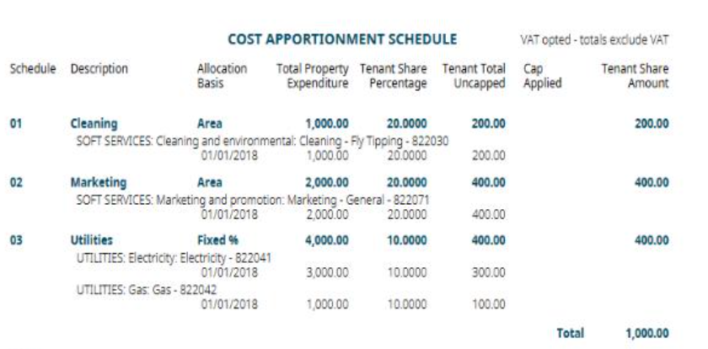
Figure 4: MRI Tenant Certificate Showing Uncapped Total as a separate figure
  - The above two results must be stored separately to be reported on separately, creating the ability for customisations to report on the first value, and even create journal postings on the basis of this calculation result.
  - The service charge module allows the process to be run as many times as needed throughout the year, and in both ‘preview’ and ‘update’ mode. Given that the actions MRI takes in response to running in either of these modes is defined by the report that is assigned to that step, and that the ending actions in these reports may be configurable, we believe it is possible to customise the functionality to make cost apportionment a period-end activity, and change the action that MRI takes in response to the service charge process being run.
  - It remains to be determined if the expense pools and unit-level settings are alone sufficient to accommodate properties with mixed service-charge types but the same entity being set up as a single building in CM, or if they would still be better off being set up as separate buildings.
- Transfer of units between entities (‘intercompany transfers’): when a regulated tenancy comes to an end, the unit may leave the purvue of the GTRUST entity and now fall under the GINVEST entity along with other PSA units. This ‘transfer’ of the unit from one entity to another may create an apparent capital gain/loss between the two entities. The question of how to deal with this is still open; however, in our assessment, we agreed that there is no question that moving a unit from one module to another at the same time as one entity to another is guaranteed to be more effort under the current design, than moving between two entities in the same module. We would need to work with Finance more closely to determine the best way to effect this unit transfer from one CM entity to another.

Other Benefits
- Reduction of performance errors: while the original vision for unit apportionment in RM planned for the splitting of invoices to occur after posting in AP, MRI was not able to deliver on the calculations needed to effect this. Instead, the split is currently being performed in GREP, resulting in multi-line invoices processed through AP. By using the built-in service charge engine to perform the calculations after posting (e.g. as a month-end activity), the performance risk is reduced.
- Simplification of Customisations: as mentioned elsewhere, the type and level of customisation in MRI has a significant impact on its risk, performance and maintainability. Additionally, it has been realised that splitting data across two modules has resulted in customisations that have to be duplicated, or that have to specifically address this split to offer an overall view. While effort to redesign these processes is not insignificant, the future burden of customisations should be greatly reduced by moving to a single module.
- Simplification of Integrations: While the effort to change existing integrations is also not insignificant, the design of the GREP logic layer will be instrumental in allowing the rework of integration logic that would be required by a move to CM. Future phases of the Connect platform will continue to reap the benefits of a simplified integration that only has to take the one module and its corresponding enumerations and tables into account.
- Avoidance of future re-implementation: there is no question that Grainger has chosen to step back and assess at the right time. Once a solution goes to production, the choices at this level are effectively locked in permanently. We have experienced many clients coming to us 5 years down the line of such a decision, either having decided that their ERP is not fit for purpose, or looking to perform a full re-implementation. Avoiding either outcome is vital to the success of the Connect Programme.

Next Steps
Given that Grainger has committed to taking a step back to review the situation, we believe there is value in taking the time to assess the feasibility and impact of an “Option 4: CM Only” approach. The assessment will require collaboration between the Grainger subject matter experts, IT, and Open Box to ensure that there are no gaps.
We would approach this assessment as follows:
- MRI upgrade and latest EMEA pack installation: Upgrade to the latest version of MRI and EMEA packs to ensure that new functionality and enhancements released since the start of the project are leveraged.
- Functionality and Process Review: Perform scenario tests, with specific Grainger use cases for the key areas of functionality:
  - Portfolio Setup
  - Service Charge
  - Unit Apportionment
  - Intercompany Transfers
- RM to CM Potential Customizations: Identify customisations required in CM to mirror functionality in RM.
- Customization Audit: Review the existing customizations and determine how they would be impacted if all portfolios are managed in CM.
- Integrations Audit: Review the existing and new integrations and determine how they would be impacted if all portfolios are managed in CM.
- Data Migration Audit: Review the migration scripts from the Legacy system determine how they would be impacted if all portfolios are managed in CM.
A more detailed statement of work will be provided should Grainger decide to proceed. At a high level, we estimate that this engagement would require between 120 – 160 hours of effort to complete.

Appendices

MRI HIERARCHY
